LOCAL LAW NO. 3 OF 2024

A Local Law to amend Chapter 200, Article VII, § 200-45.3 regarding
Supplementary Use Regulations for Solar Energy Systems.

Section 1. Chapter 200, Article VII, § 200-45.3 regarding Supplementary Use Regulations for Solar Energy Systems, as added October 7, 2004 by Local Law No. 4-2004, shall be amended, in its entirety to read as follows:

§ 200-45.3 Solar energy systems.

A. Purpose. To insure that any solar energy system shall be erected or installed so that the system is designed to be aesthetically appropriate for the intended location as determined and approved by the Architectural Design Review Board (ADRB) and a permit has been issued, and that in the judgment of the ADRB the proposed panels are architecturally and aesthetically acceptable and consistent with similar equipment installations in the Village of Garden City.

B. Definitions. As used in this section, the following terms shall have the meanings indicated, unless the context otherwise indicates:

ABUTTING STREET(S)
Street that shares a boundary with the subject property; or in the case of a corner property that shares a boundary with more than one street.

INTEGRATED PRIMARY EQUIPMENT
Any part of a solar energy system that is built into a structure and blends aesthetically and functionally into that structure including but not limited to: integrated solar roof tiles, solar slates, or solar shingles.

NON-INTEGRATED PRIMARY EQUIPMENT
Any part of a solar energy system that is not built into a structure and does not blend aesthetically and functionally into that structure including but not limited to solar panels.

PRIMARY EQUIPMENT
Any photovoltaic cell(s), water panel(s), or other devices that convert, absorb, or transform solar energy.

SECONDARY EQUIPMENT
Any supply lines, return lines, control valves, wiring, meters, switches, modules, inverters, or other devices and cabinets associated with the installation or function of a solar energy system.

C. Regulations.

(1) General. All solar energy systems shall be designed, erected and installed in accordance with all applicable codes and standards.

(2) As much as possible, all panels, tiles, or slates are to match the color of the roof or wall to which they are attached.

(3) On buildings or accessory structures with flat roofs where tilted frames are used, such equipment shall not be visible from abutting streets. If necessary, the equipment shall be screened with appropriate material as approved by the ADRB.

(4) Primary equipment mounted to an approved accessory structure shall be considered part of that structure and is subject to all the requirements of
§§ 200-52 and 200-55. Such equipment is also subject to approval by the
ADRB.

(5) All secondary equipment associated with any solar energy system installation shall not be exposed on the outside of any structure unless required by applicable codes and standards.

(6) Integrated equipment may be mounted on any roof if, in the judgment of the ADRB, the equipment resembles, integrates, and blends seamlessly with the overall aesthetics and architecture of the structure and conforms to all the other requirements related to solar panels contained in this section of the code.

(7) Non-integrated equipment added to an existing structure shall be installed parallel to and directly against the existing sloping roof and shall be located in an area of the roof that is not visible from an abutting street. Individual modules must, to the extent possible, be arranged as a single integrated unit located on the roof and centered on the roof section, substantially covering the entire roof (allowing for necessary areas to provide walkways and other necessary access areas) so as to provide a single,

consistent and unified look to the roof. This includes the panel frames and other visible hardware on or adjacent to the panels. In the event that the panels do not substantially cover the entire section of the roof, they must be located on that part of the roof that is not visible from the abutting street(s), assuming compliance with other provisions of this section.

D. Building Permit Submission requirements.

(1) All solar panel applications must first be submitted to the Building Department for a preliminary review demonstrating compliance with the requirements specified herein.

(2) All applications must include color photographs of the subject property to illustrate the location and visibility of roof surfaces from the street. Photographs must be taken from five points along the centerline of the abutting street (or streets for corner properties). Points shall be equally spaced between lines drawn at a 45-degree angle from both sides of the intersection of the centerline of the property with the front elevation of the structure. Photo locations are identified as “A” through “E” on Figures X and Y; Figure X illustrates a structure located mid-block (facing one street) and Figure Y illustrates a structure located on a corner.

Section 2. Effective Date

This Local Law shall take effect immediately upon filing in the office of the New York Secretary of State in accordance with the Municipal Home Rule Law.

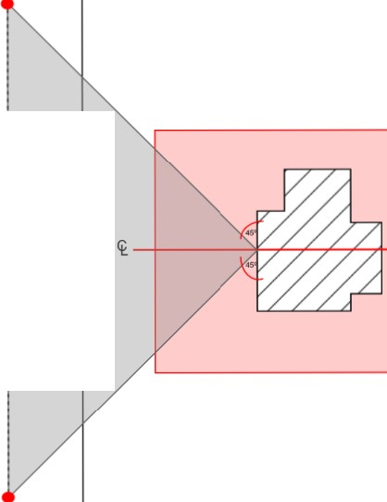A

B Midpoint

c ...._---+--

O Midpoint

E .
'
'
'
'
'

FIGURE X- Mid-block

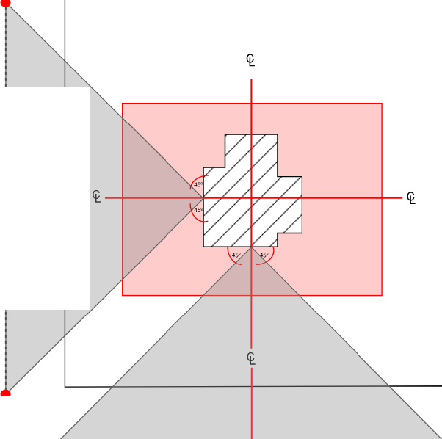A

8 Midpoint

c .-- -+-

D Midpoint

E .
.

.
<t ......

.-·· --- - - ....... -- .............j------- '"""""""il........--- ---.

<t A
B c D E

FIGURE Y - Corner Property

